**Quickstart Requirements:**

All processed documents’ data must include a single variable ‘metaData’ which is a map.

All data related to the program must be saved in ‘metaData’.

For successful processing, these key-value pairs are required in metaData:

* + string ‘state’ => string [whether or not to process: create to start]
  + string ‘template’ => string [file name and extension of the template]
  + string ‘inBucket’ => string [exact name of GCS bucket]
  + string ‘outBucket’ => string [exact name of GCS bucket]

For example:

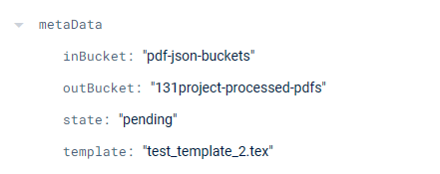

General data related to the template will never be found in metaData.

There is no expected format for template related data.

**Possible ‘metaData’ Fields:**

**A list of all the currently implemented fields for use in the metaData map.**

**This list is not comprehensive: only including fields that affect program execution.**

**All fields are case-specific!**

* dependencies [map]

Value: Key [string] => File name as expected in Cloud Storage Buckets. Files are assumed to be required to compile the template into PDF. E.g. images.

Value [string] => Bucket name as expected in Cloud Storage. The expected bucket the file is stored in. Since keys are unique, the map object values must be the bucket strings.

Example:

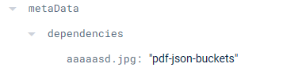

* emailContent [string]

Value: Plain text replacement for email subject through SendGrid API.

* emailSubject [string]

Value: Plain text replacement for email-body contents through SendGrid API.

* inBucket [string]

Value: Bucket name as expected in Cloud Storage. Default bucket for downloading files. Expected bucket for unprocessed template.

* outBucket [string]

Value: Bucket name as expected in Cloud Storage. Default bucket for uploading files. Expected bucket for processed template.

* receivingEmails [array]

Value: [string] => List of only strings. Each string is an email to receive the finished PDF through SendGrid.

* saveFilledTemplate [boolean OR string]

Value: Value type is interpreted by the program.

[boolean] => Whether or not to save the filled template before PDF conversion.

[string] => Bucket name as expected in Cloud Storage. Saves the filled template here if the bucket exists.

* sendEmail [boolean]

Value: True or False => Whether or not to activate SendGrid API.

* state [string]

Value: Document status specifier. Requires expected, case-sensitive inputs. No enumerator specifier / class defined.

Potential Values: ‘create’, ‘completed’, ‘ERROR’ => ‘create’ triggers processing.

* template [string]

Value: File name as expected in Cloud Storage Buckets.